**Node Embedding**

Given an input graph, extract node, link and graph-level features, learn a model (SVM, neural network, etc.) that maps features into labels.

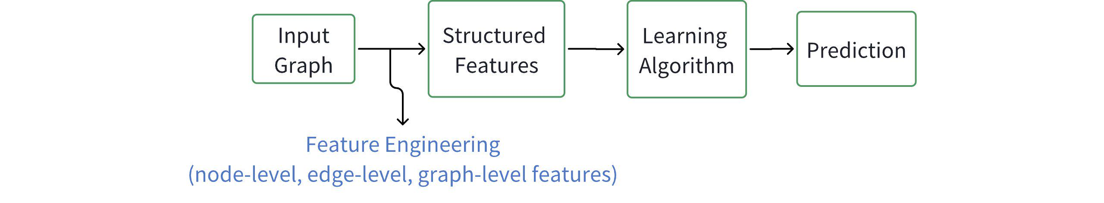

Embedding: map node in graph into form of vector $v$, . Construct mapping . $v$ is then a feature presentation (so call embedding).

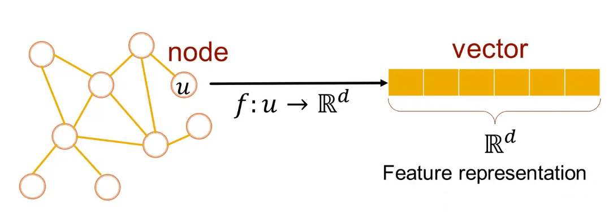

Why Embedding?

* Similarity of embeddings between nodes indicates their similarity in the network.
* Encode network information
* Potentially used for many downstream predictions.

Example Node Embedding

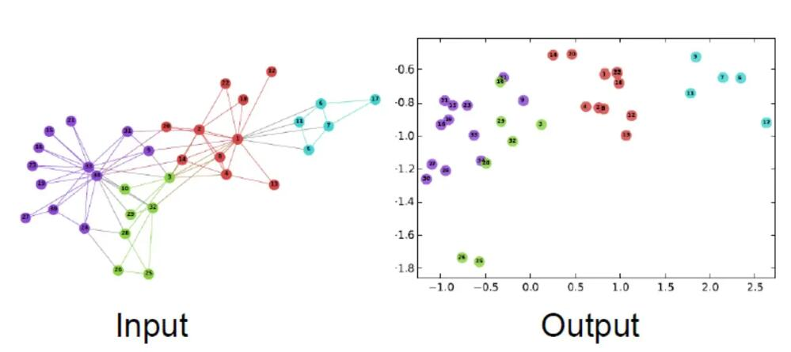

Map the node in graph into n-D space vector, then project these vectors in 2-D plane, which is shown in "Output".

Goal is to encode nodes so that similarity in the embedding space (e.g, dot product) approximates similarity in the graph.

$similarity\left(u , v\right)≈z_{v}^{T}z_{u}$

And the similarity should be defined in Mathematics.

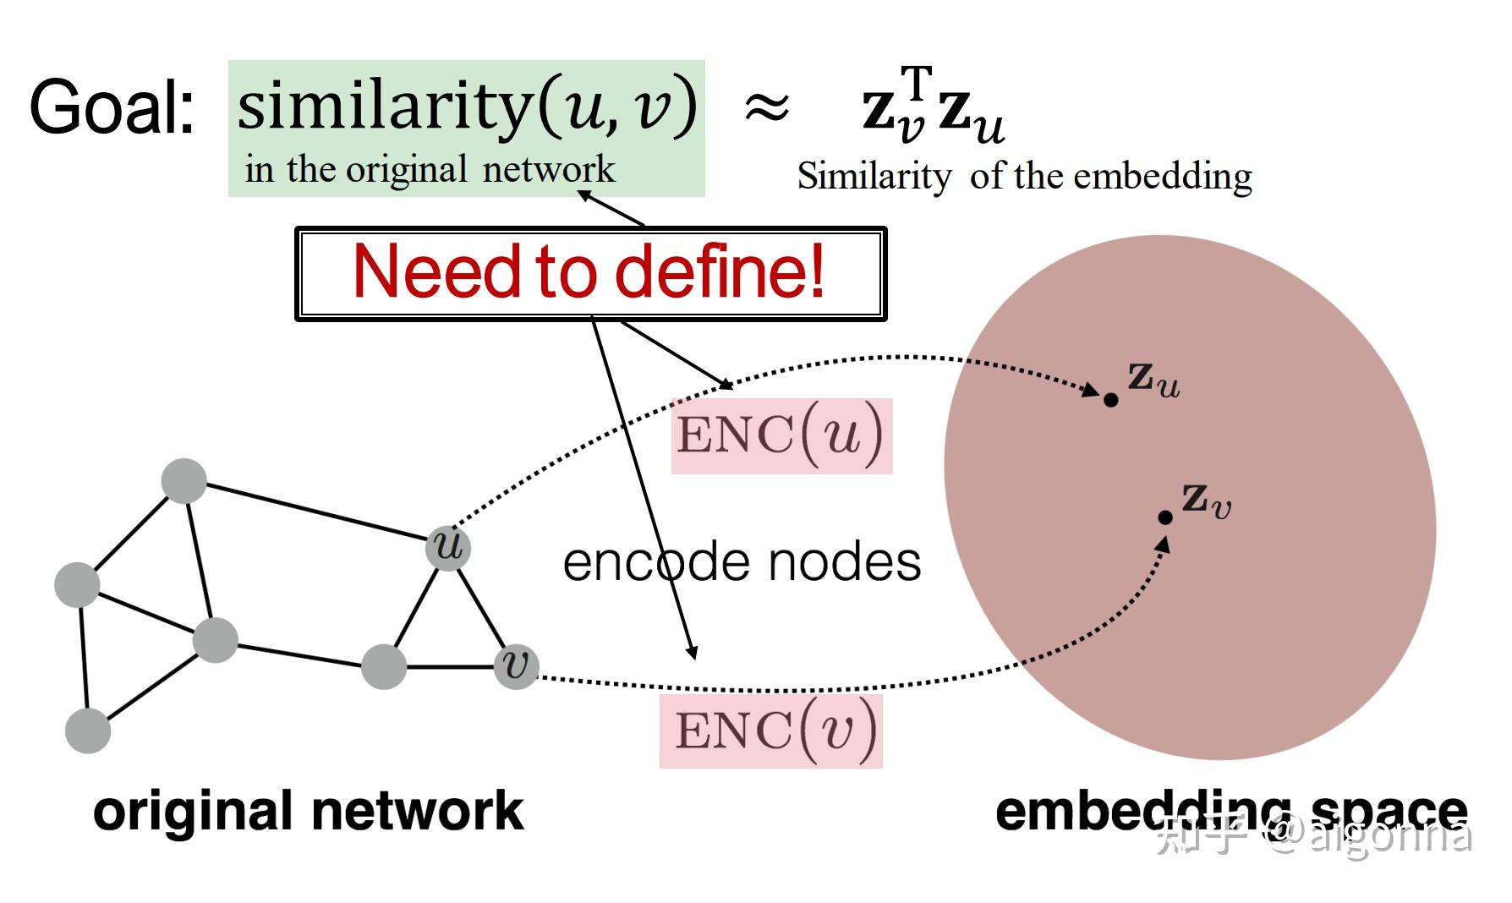

1. Encoder maps from nodes to embeddings.
2. Define a node similarity function
3. Decoder DEC maps from embeddings to the similarity score.
4. Optimize the parameters of the encoder so that: $similarity\left(u , v\right)≈z_{v}^{T}z_{u}$

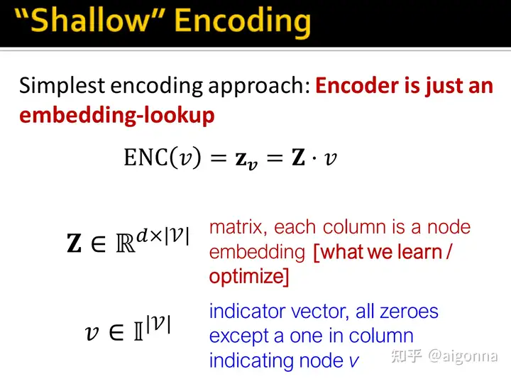

Personal understanding: the learning goal is to find optimal matrix $Z$, so that $similarity\left(u , v\right)≈z_{v}^{T}z_{u}$.

Each node is presented as one dimension in space. $v$ may like ${\left[0 , 0 , 1 , 0 , 0\right]}^{T}$

The matrix $Z$ was called embedding matrix.

The approach of learning and optimization include DeepWalk and node2vec.

How to define node similarity?

* This is unsupervised/seld-supervised way of learning node embeddings.
* The goal is to directly estimate a set of coordinates of a node so that some aspect of the network structure (captured by DEC) is preserved.
* These embeddings are task independent.
* They are not trained for a specific task but can be used for any task.

Notation

* Vector $z_{u}$
* The embedding of node $u$ (what we aim to find)
* Probability $P\left(v|z_{u}\right)$
* The predicted probability of visiting node $v$ on random walks starting from node $u$.

Non-linear functions used to produce predicted probabilities

* Softmax function

K-vector $\left[p_{1} , p_{2} , ... , p_{k}\right]$ (model predictions) into K probabilities that sum to 1: $σ\left(z\right)\left[i\right]=\frac{e^{z\left[i\right]}}{\sum_{j=1}^{K}{}e^{z\left[j\right]}}$ for example, 0.2, 0.4, 0.35, 0.05 ($k=4$)

* Sigmoid function

S-shape function that turns real values into the range of (0, 1). $S\left(x\right)=\frac{1}{1+e^{-x}}$

Random Walk

$z_{u}^{T}z_{v}≈$ Probability that $u$ and $v$ co-occur on a random walk over the graph.

1. Expressivity: Flexible stochastic definition of node similarity that incorporates both local and higher-order neighborhood information.

Idea: if random walk starting from node $u$ visit $v$ with high probability, $u$ and $v$ are similar (high-order multi-hop information)

1. Efficiency: Do not need to consider all node pairs when training; only need to consider pairs that co-occur on random walks.

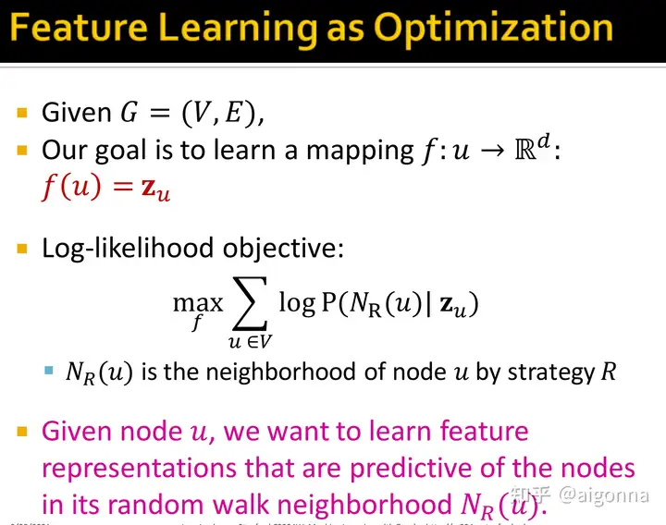

Random Walk Optimization

1. Run short fixed-length random walks

Starting from each node $u$ in the graph using some random walk strategy R.

1. For each node $u$ collect $N_{R}\left(u\right)$, the multiset of nodes visited on random walks starting from $u$.
2. Optimize embeddings according to: Given node $u$, predict its neighbors $N_{R}\left(u\right)$.

$max_{f}\sum_{u∈V}{}logP\left(N_{R}\left(u\right)|z_{u}\right)$ ==> Maximum likelihood objective

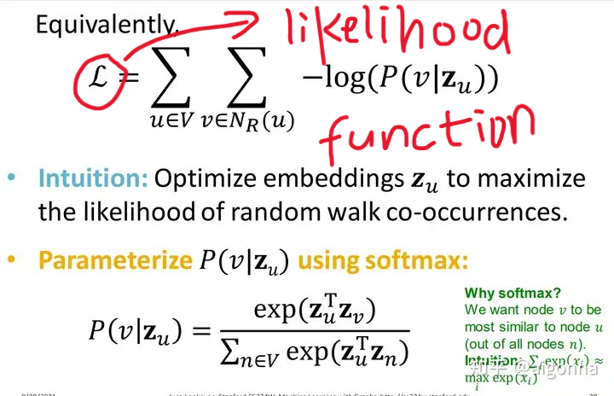

Note

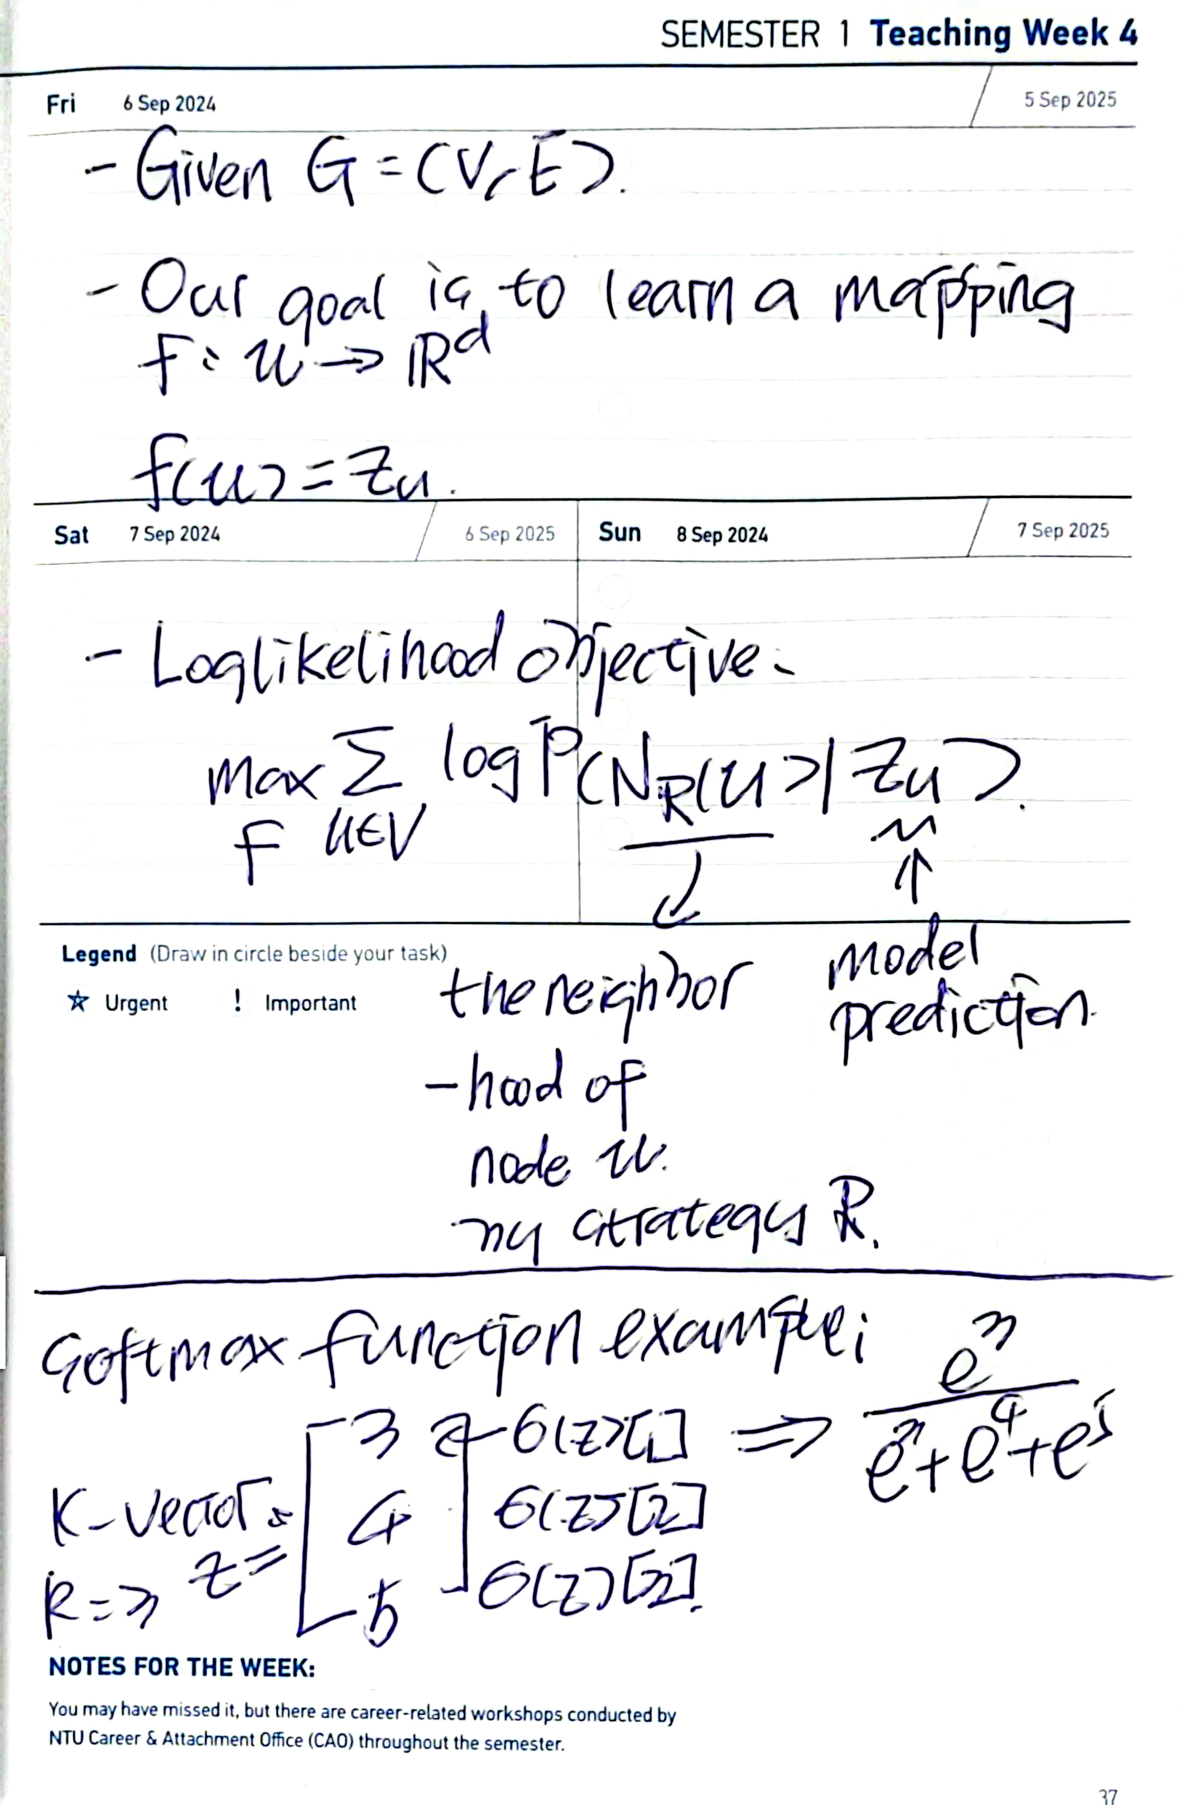

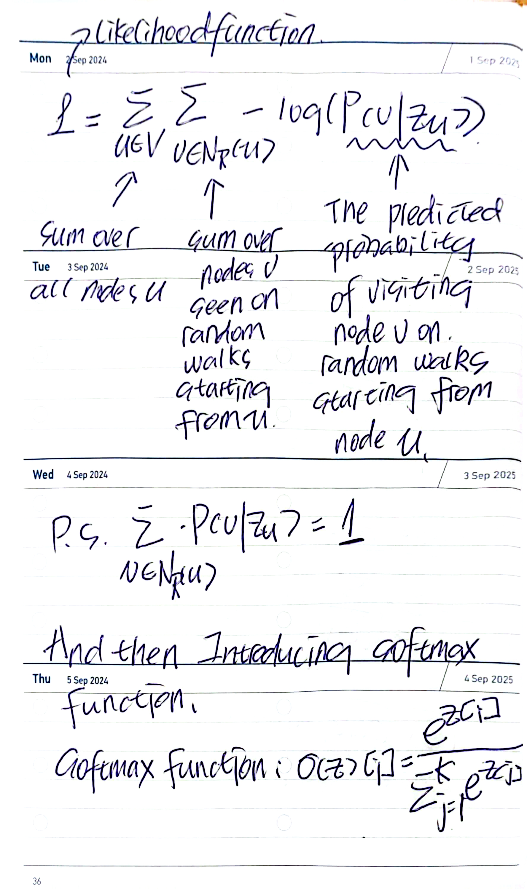

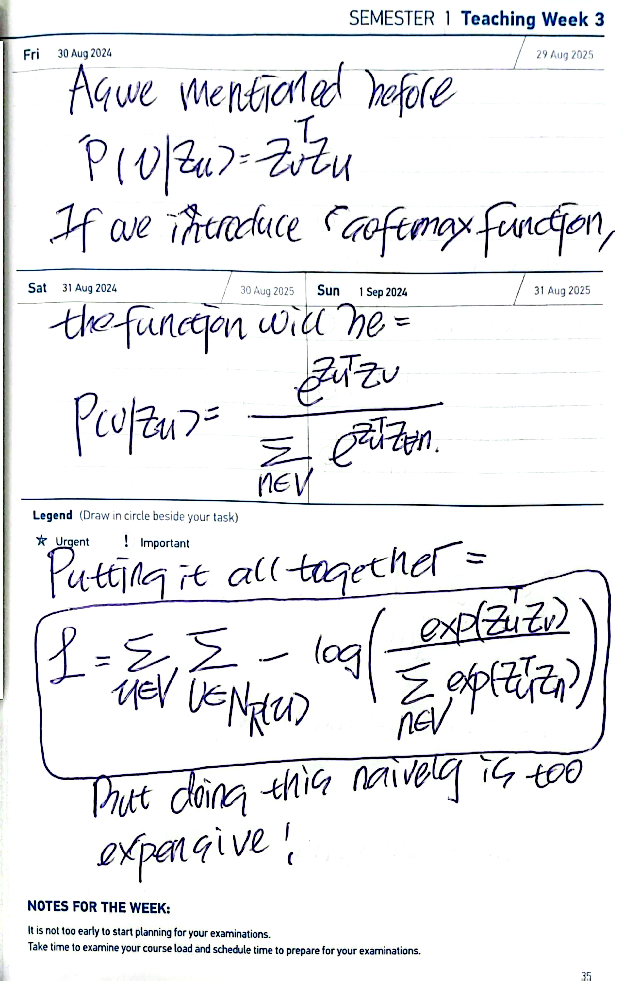

Advantages of DeepWalk

* Scalable: Linear time complexity in the number of nodes
* Unsupervised: No need for node labels
* Versatile: Applicable to various graph types (directed, weighted)
* Preserves higher-order proximity

Limitations of DeepWalk

* Ignores node attributes/features
* Uniform random walks may not capture complex graph structures
* Limited ability to capture global graph structure

node2vec

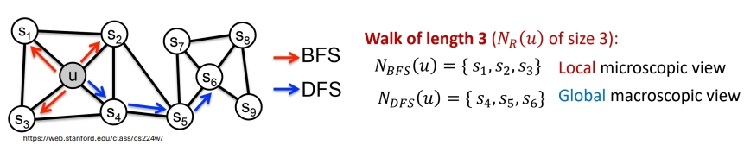

Seen to mainly focus on **optimizing random walking strategies**.

Idea of node2vec: Biased Walks

Use flexible, biased random walks that can trade off between local and global views of the network.

Two parameters

1. Return parameter p

Return back to the previous node

1. In-out parameter q:

* Moving outwards (DFS) vs. Inwards (BFS)
* Intuitively, q is the "ratio" of BFS vs. DFS

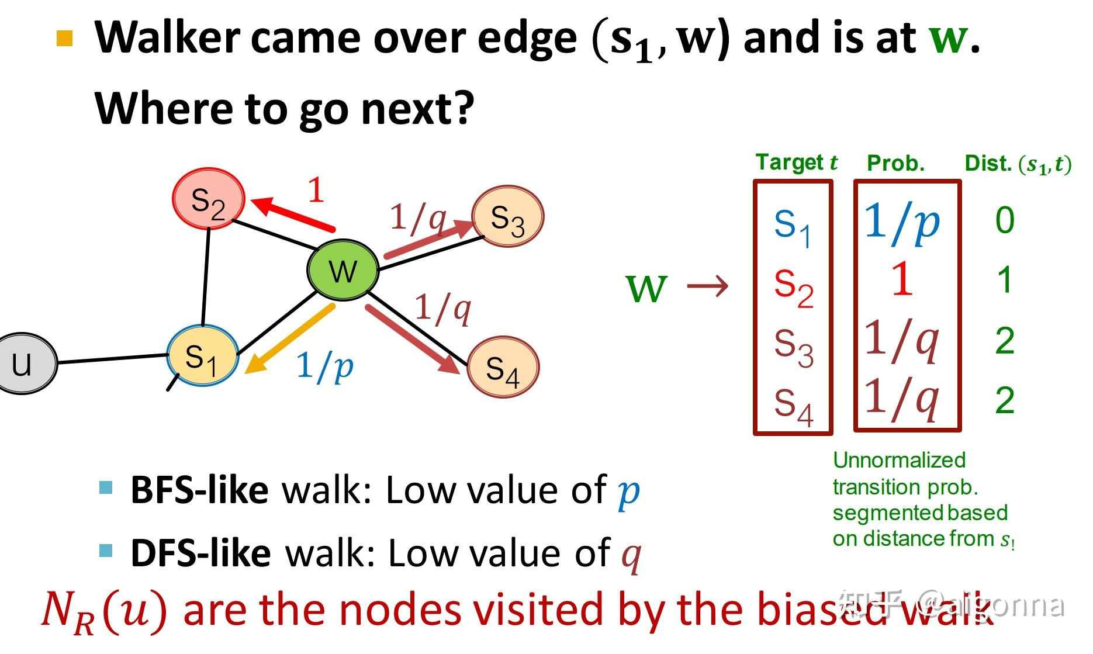

Explaination:

Walker came over edge $\left(s_{1} , w\right)$ and is at $w$. Where to go next?

* Parameters we set: p, q - model transforming probability.

Last node is $s_{1}$ and the next node could be $s_{1},s_{2},s_{3},s_{4}$.

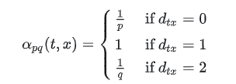

Recommanding Reading

[zhuanlan.zhihu.com](https://zhuanlan.zhihu.com/p/486094620)

[zhuanlan.zhihu.com](https://zhuanlan.zhihu.com/p/488432274)